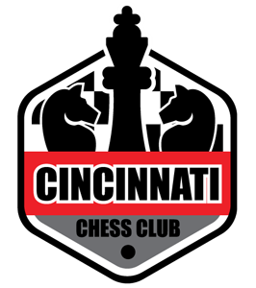Beginner Chess Curriculum and Logistics
(new player to 800 rating)
- The chessboard
- Piece Identification and how to set the pieces up
- How the Pieces move
- Check and check mate
- Insufficient material
- Stalemate
- Chess notation
- Exercise follow the notation to find the resulting position on the board
- Chess clock basics
- How the game ends
- Exercise Pawn Game
- Exercise King and Pawn game
- How to check mate(K+R, K+Q, K+2R)
- Exercises(K+Q checkmate, K+R check mate, K+2R)
- Practice Checkmate exercises
- Tactical tool box
- Overall strategies based on phase of the game(opening, middle game, end game)
- Chess etiquette
- What to expect at your first tournament
- Play chess against classmates
Appendices:
- Answers to exercises
- Other named checkmate patterns
- Example chess training plan
- Do I need a chess Coach?
- Resources for improving your game
Meeting logistics:
Prerequisites: none
Time : Jul 14 8:30AM-12:00PM, July 15 8:30AM-!2:00 PM
Be prompt the class will start on time
Location: Friendship United Methodist church
1025 Springfield Pike, Wyoming, OH 45215
Snack: a midmorning snack and water will be provided
Age Range: 8 years old and up
Course material: A training booklet will be provided that you can follow along with during class and take home for future reference. The appendix information is for your future reference and will not be covered during the class time.
The club will provide chess sets and clocks for use during the training session
Class size: The class size is limited to the first 30 people to register
Sign up: Sign up on the Cincinnatichessclub.com website by credit card or paypal. There is no on site registration. The cost of the course is $75.
Sign up deadline: July 1, 2023
Sign up information:
First Name
Last name
Telephone number of adult or parent
E-mail address of adult or parent

